Project Design Phase-II Customer Journey Map

|  |  |
| --- | --- |
| **Date** | **16 NOVEMBER 2022** |
| **Team ID** | **PNT2022TMID49204** |
| **Project Name** | **Natural Disasters Intensity Analysis And Classification Using Artificial Intelligence** |
|  |  |

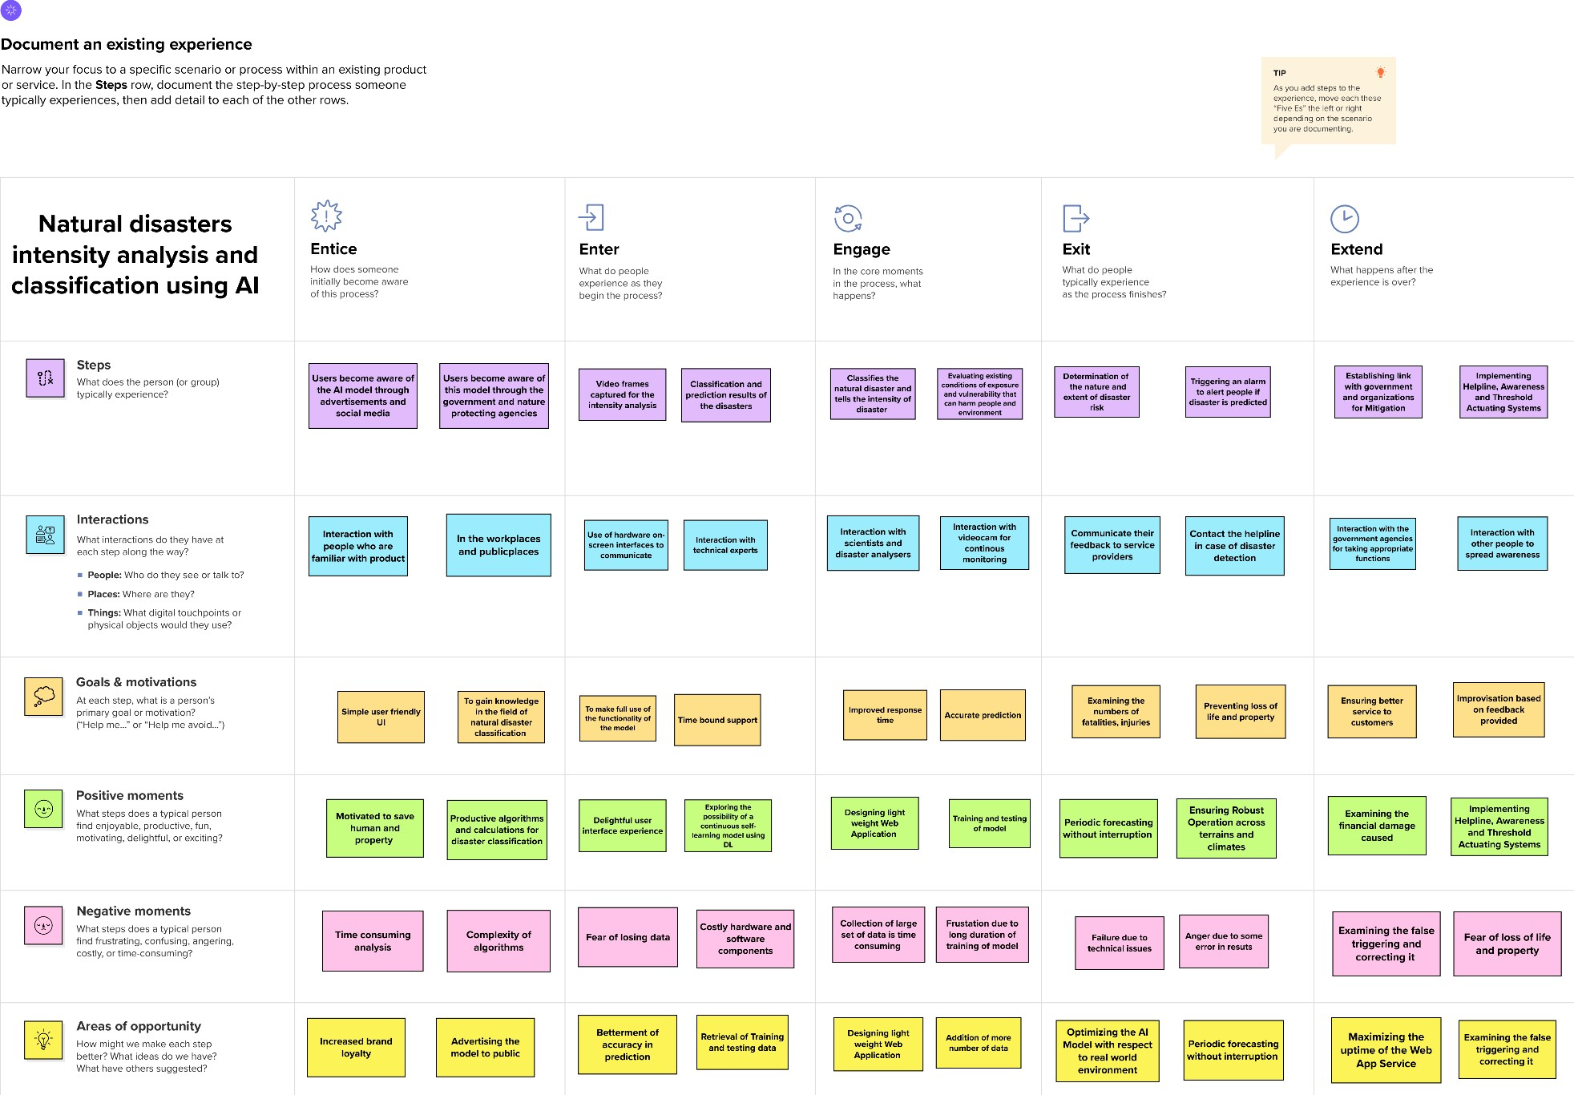CUSTOMER JOURNEY MAP